1. Telemetry IC (U6) 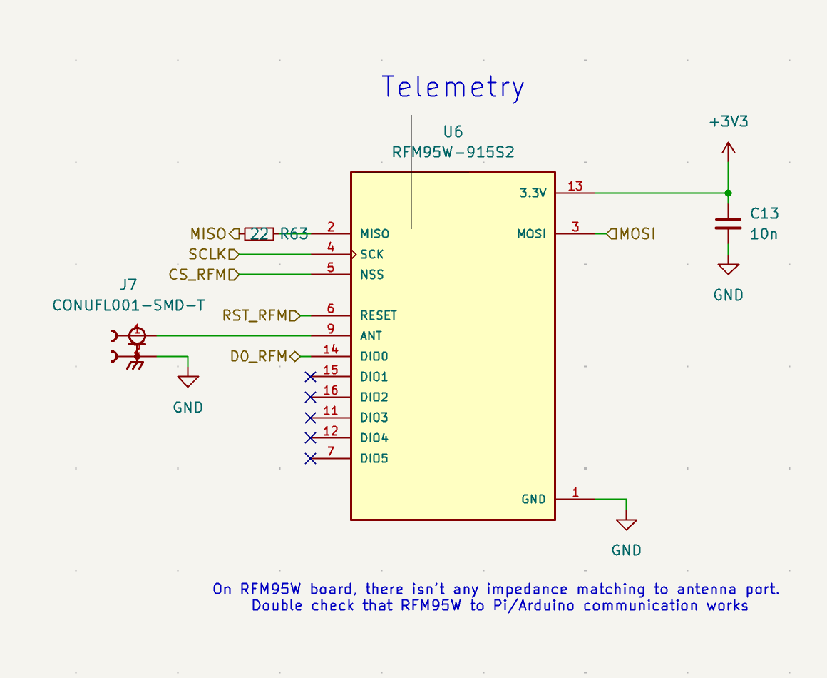
I got the impression that you plan to use the same breakout board from Adafruit: https://www.adafruit.com/product/3072#technical-details
So I use the breakout board’s schematic as a reference (the schematic uses RFM69 chip, which has the same pinout as RFM95):
https://learn.adafruit.com/assets/31773
Please see below are my comments for this chip:
- Then C13 should be 10uF, not 10nF
- Pin 6 the RST_RFM reset pin, is floating on Page 1. According to the datasheet, it's pulled high by default which is reset. Pull LOW to turn on the radio. So, should it be connected to any pin on the MCU?
- The same for Pin 14, the D0_RFM pin, is also floating on Page 1. It should be connected to a hardware Interrupt pin on the MCU. Check your MCU, not all pins can be used as hardware interrupt pins.
- About the antenna, the datasheet (https://www.hoperf.com/uploads/RFM96W-V2.0_1695351477.pdf)of the chip says 50 ohms to match the chip on Page 13. So any 50 ohms antenna would work. On the Adafruit website, it uses a dipole or a wire. I see there is an ufl snap-on connector on your schematic, so I assume you plan to use antenna? This is fine, but just so you know that the snap-on connector is a bit tricky to work with. If possible, the board size allowed, I would still use screw-on sma connector for the antenna, something like this: https://www.mouser.com/en/ProductDetail/RF-Solutions/CON-SMA-EDGE?qs=UkDUCjYnTB3wOPRCaplkvw%3D%3D&mgh=1&utm_id=22019447991&utm_source=google&utm_medium=cpc&utm_marketing_tactic=amercorp&gad_source=1&gad_campaignid=22019464944&gbraid=0AAAAADn_wf1oXa4vGJNAe7YoWUm6eWXvc&gclid=CjwKCAjw_KjVBhAHEiwAnC0N9Ivx6XLniPPf4AdUVHCkmLyQ5gutAK3xjG-MHqx4dfnls6K0Zhhm7hoCGQQQAvD_BwE
- Maybe move R63 (22ohms) to page 1, for a better understanding, since you also have this small anti-reflection (I guess this is your purpose?) resistors on all the other SPI pins on that page, e.g., R40-R42

2. Altimeter IC (U5) 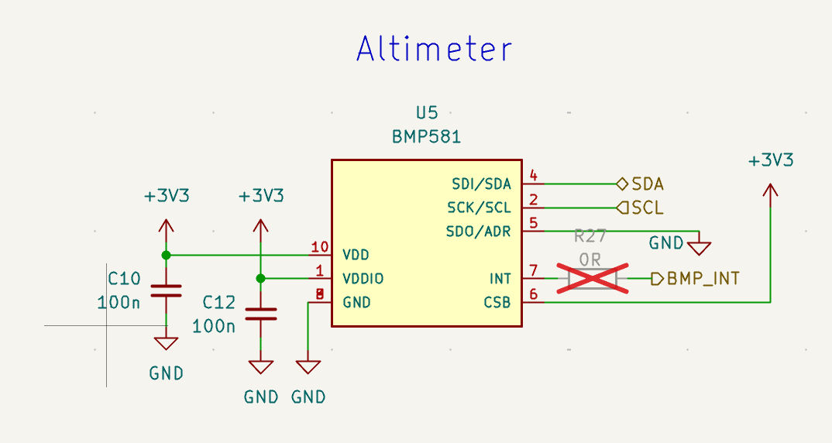
I used the Adafruit BMP sensor website as a reference: https://learn.adafruit.com/adafruit-bmp580-bmp581-and-bmp585-temperature-and-pressure-sensor
Below are my comments:
- You grounded SD0, so remember the I2C address will be 0x46 instead of the default 0x47.
- Pin 7, the BMP_INT pin is floating on Page 1. There’s no R27, right? Do you plan to use this interrupt pin? If so, it should be connected to a MCU pin.
- Pin 6, CSB pin, should be pulled High to use I2C. Missing a pull-up resistor there.
- Can you just directly connect Pin 1 and Pin 10? I don’t quite understand why they need to connect to 3.3V separately.

3. Micro SD Port (J9)
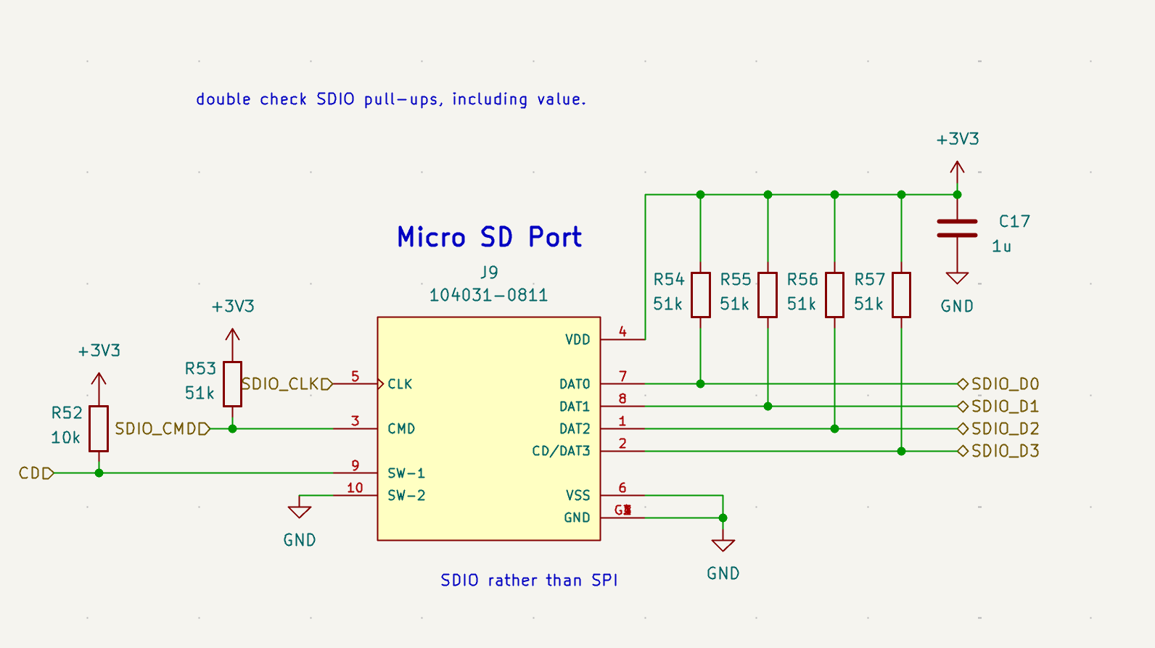
I couldn’t find any useful pinout datasheet of this connector from the library website: https://www.snapeda.com/parts/104031-0811/Molex/view-part/?ref=eda . So I just used this Adafruit microSD card as a reference: https://learn.adafruit.com/adafruit-microsd-spi-sdio/pinouts
Below are my comments:
- The 3.3V power pin, the reference uses two capacitors 10uF and 0.1F, with the 3.3V power. I didn’t quite understand the 10uF at the beginning, but after some search, it seems quite common for SD car readers, because: the 10uF acts more like a back-up battery to main a stable power rail while reading/writing the card; the 0.1uF is just the high-frequency decoupling as commonly seen for power pins.
So I would also suggest you replace the 1uF C17, by these two separate capacitors.
- Pin 9, SW-1. Again, given no pinout for this port, I don’t know how to align this pin to the pins in the reference. Does it need pull-up, and is 10k a good pull-up value?
- The reference uses 47k ohms for all the pull-up resistors. Any reason you chose 51k?

4. Primary IMU (U4)
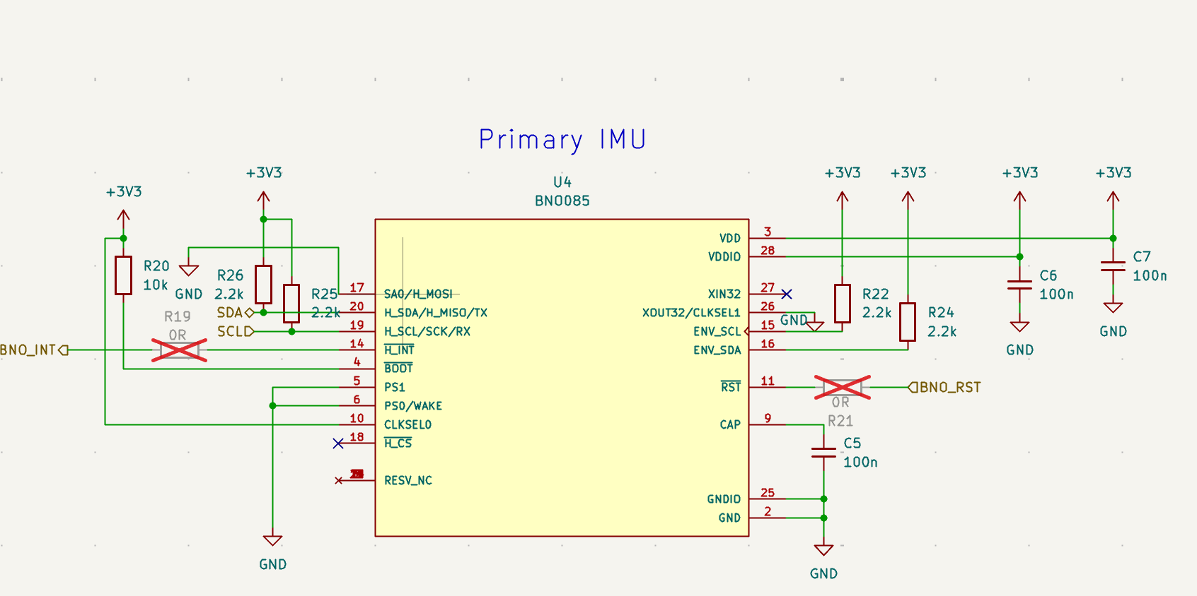
I used Adafruit breakout board for reference here: https://learn.adafruit.com/adafruit-9-dof-orientation-imu-fusion-breakout-bno085/downloads
As well as the chip datasheet: https://www.ceva-ip.com/wp-content/uploads/BNO080_085-Datasheet.pdf , mostly just Figure 1-11 on Page 13, since you are using I2C on this chip.
Below are my comments:
- Power pins, Pin3 and 28, the Adafruit reference directly connected pin 28 to 3, and then to 3V3 with a 0.1uF capacitor. The chip reference uses two 0.1uF capacitors. I am not exactly sure how necessary it is.
- Rest pin, Pin 11, BNO_RST, is floating on Page 1. Should it be connected to any pin on the MCU?
- Interrupt pin, Pin 14, is floating on Page 1, should be connected to a GPIO pin on the MCU.
- Boot pin, Pin 4, is recommended to be connected to a GPIO pin, as mentioned on Page 13 of the second reference, “to use the device firmware update (DFU) capability of the BNO08X”. But if you run out of GPIO pins, it’s probably fine not connecting it.

